Contents

**Introduction** 2

**Task 1 (HTML)** 2

**Researched relevant content** 2

**Running the web page in two web browsers in mobile** 4

**Running the web page with Opera browser on mobile.** 5

**Home page** 6

**Shop Page** 8

**About us Page** 9

**Contact us page** 11

**Login page** 12

**Task 2** 13

**External CSS** 13

**Tasks-3** 21

**Test the website and write a test report** 21

**Problems while testing and recommendation for fixing them** 21

**Testing with relevant screen reader** 22

**Discrepancies and identify and rectify their causes** 22

**Differences between two browsers** 24

**Report** 27

**Task-4** 27

**The suitability of the tools, techniques and software used to develop the website** 27

**(b) how intuitive interfaces contribute to delivering an improved user experience** 28

**(c) Suitability of the accessibility** 28

**(d) Recommend improvements for further development of the website** 28

References 29

# **Introduction**

There are many standing desks in our website. You can choose what desks what you wanted and order by visit our “matter” website. It helps the users by saving time by shopping to mall and industry. Our desks are made currently design and reliable for users. After clink sign up, users will need to go to the login page. On the login page, the users will enter the details users used to register, as users ‘name and password. When the users are logged in, the user can order and book for any standing desk.

# **Task 1 (HTML)**

# **Researched relevant content**

**Home page**

The Home page include the navbar at the top. And the currently items are placed.

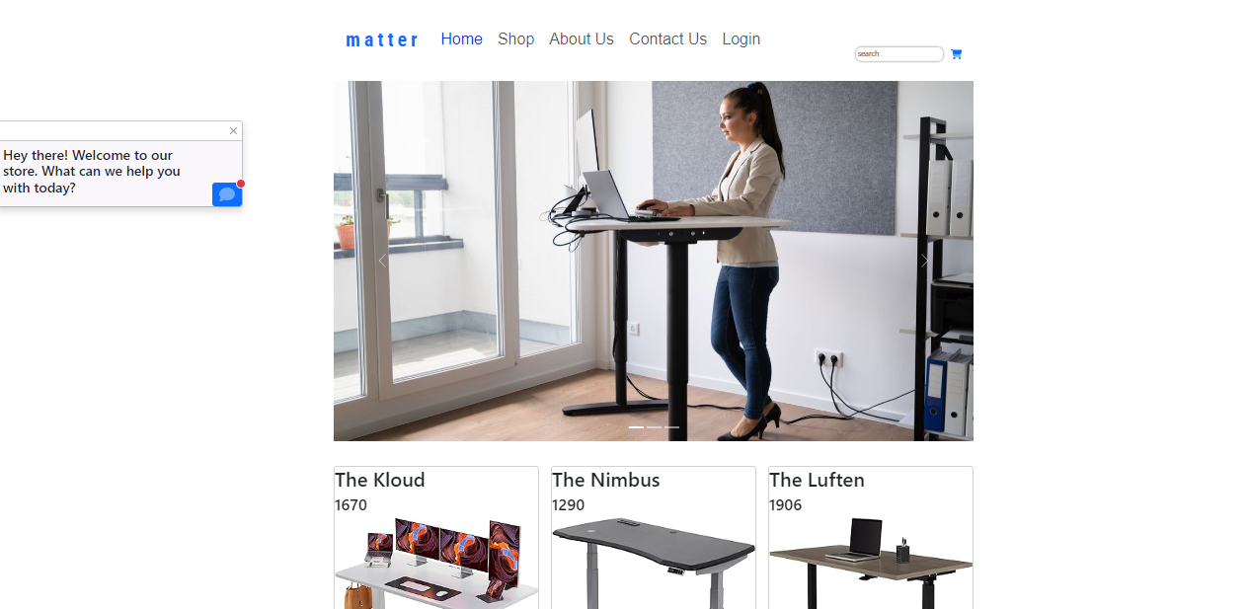

**Shop page**

This age includes the products and the user can order and read preview.

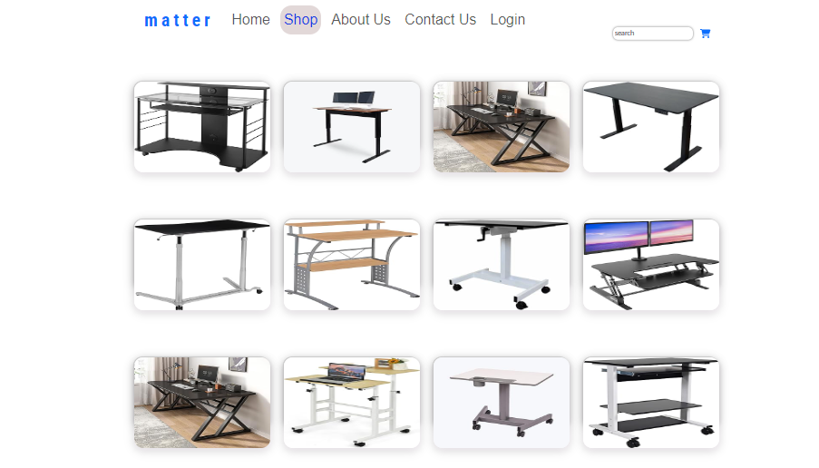

**About us**

This page includes the benefit the users for using the products.

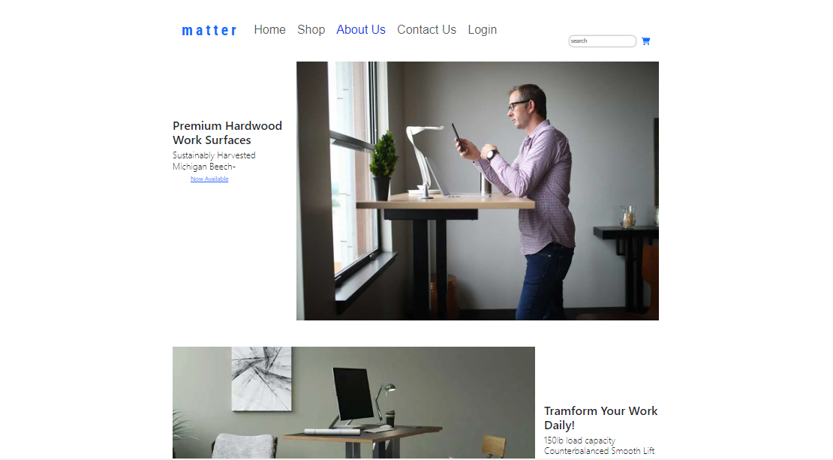

**Contact us**

This page includes the form for user to submit.

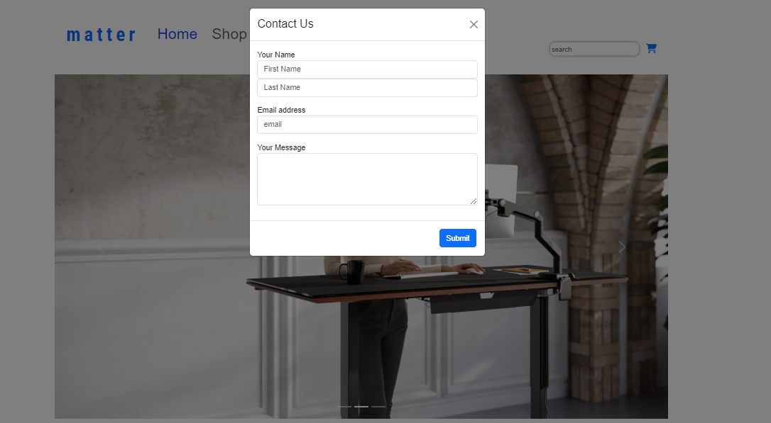

**Login**

This page includes the form that are needed for users to create account and login.

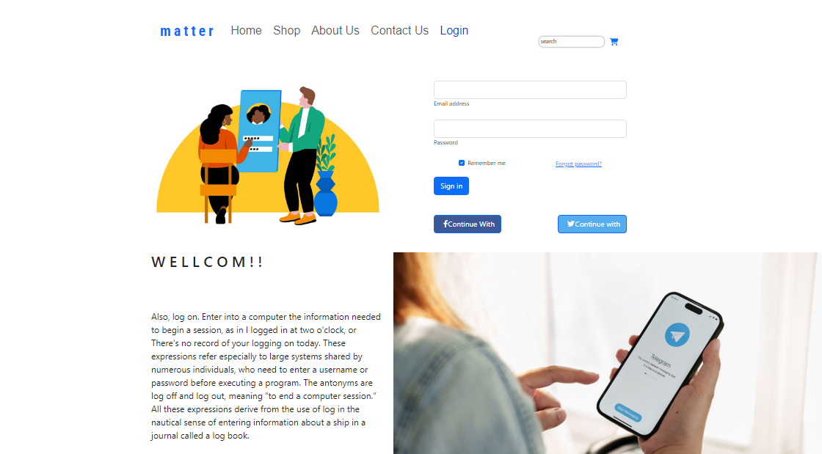

## **Running the web page in two web browsers in mobile**

Running the web page with Chrome browser on mobile.

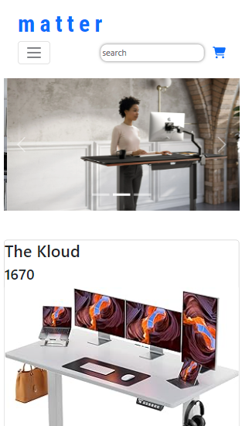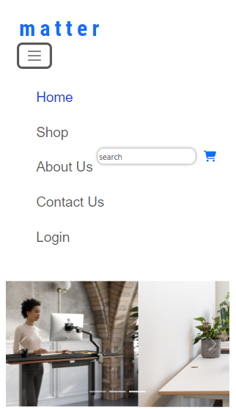

## **Running the web page with Opera browser on mobile.**

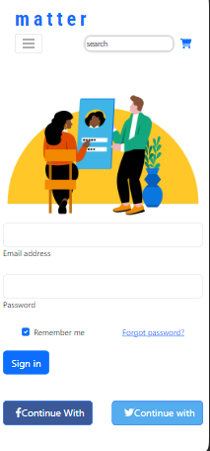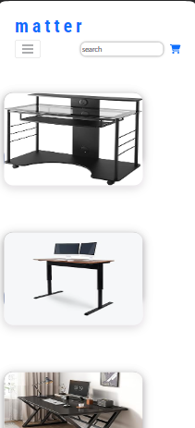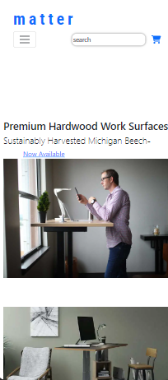

### **Home page**

This Home page include the “HELLO” message box for the advisor to our website page. This box is coming at the first for the statement of “WELCOME”. The slide show also contains in the home page that include three photo contents for daily life with using desk for smart. And the search box and bracket are placed the right of page. This “HELLO” message can info for visitor at first time.

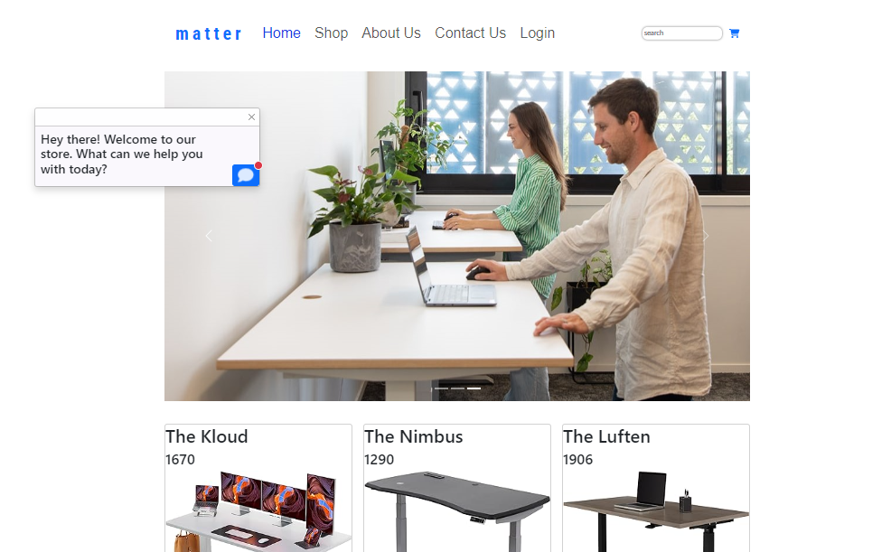

The section of the Home page contains the current items that are place in a card with three column and each cards show the name, code, price and the logo of price. At the footer include the company of name, Matter and logo. This also container the link of Facebook, Instagram, Twitter.

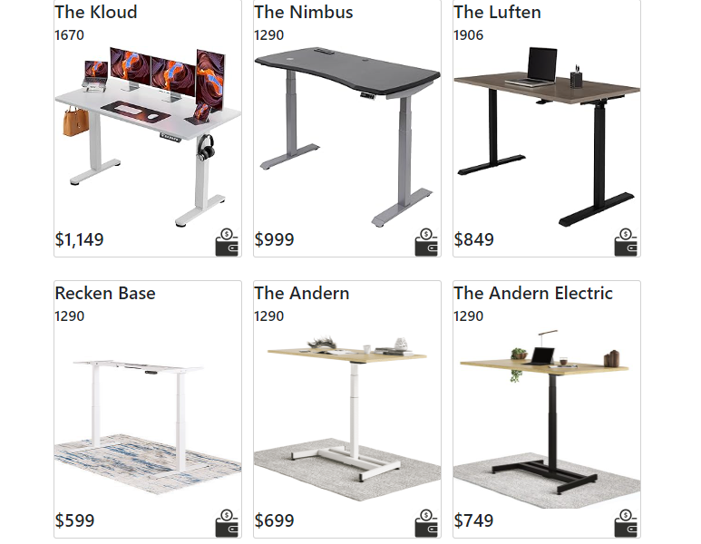

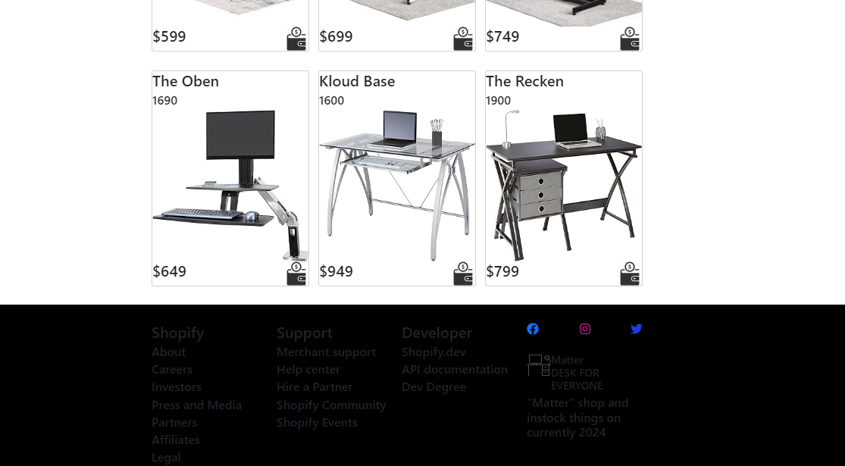

### **Shop Page**

This page shows the items that are available. This include four column and each item is placed in a card and the card is decorate with “hover” in CSS.

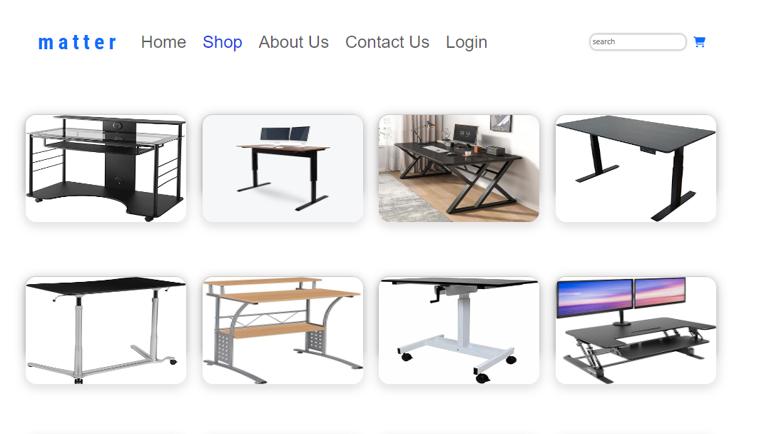

Clinking each item, the width is extended and show the name, price and buttons. When open order button, we arrive Login page to login for order items and preview button is the content of items.

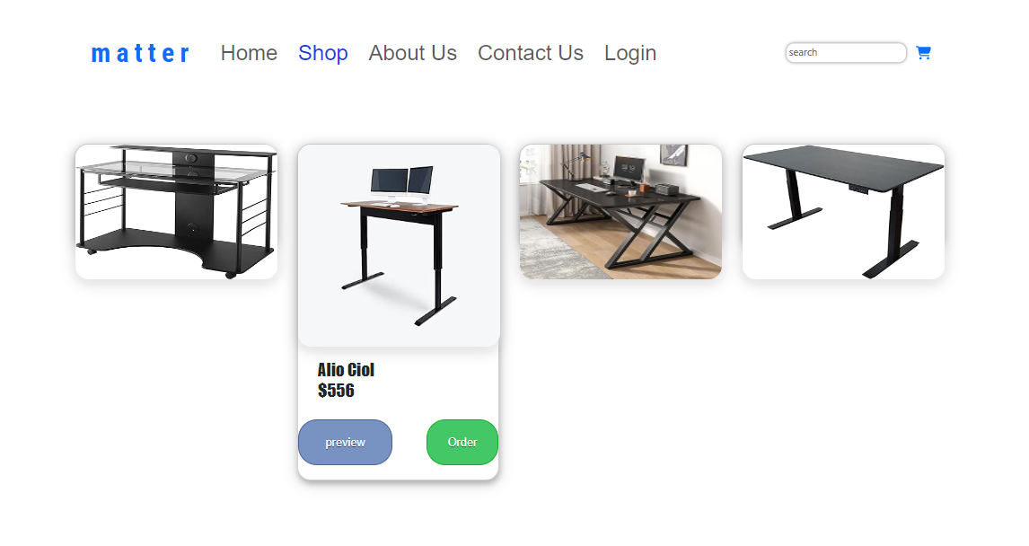

### **About us Page**

This page shows the benefit for customers for using our products.

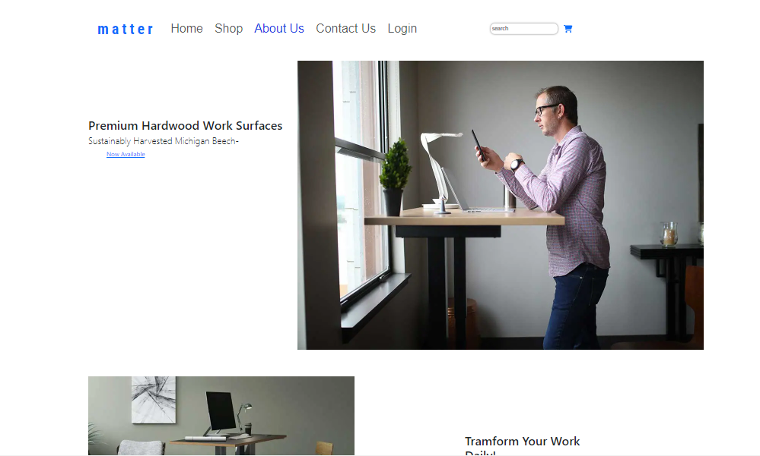

The content photo and words include and clinking each button will arrive shop pages and they look for our products.

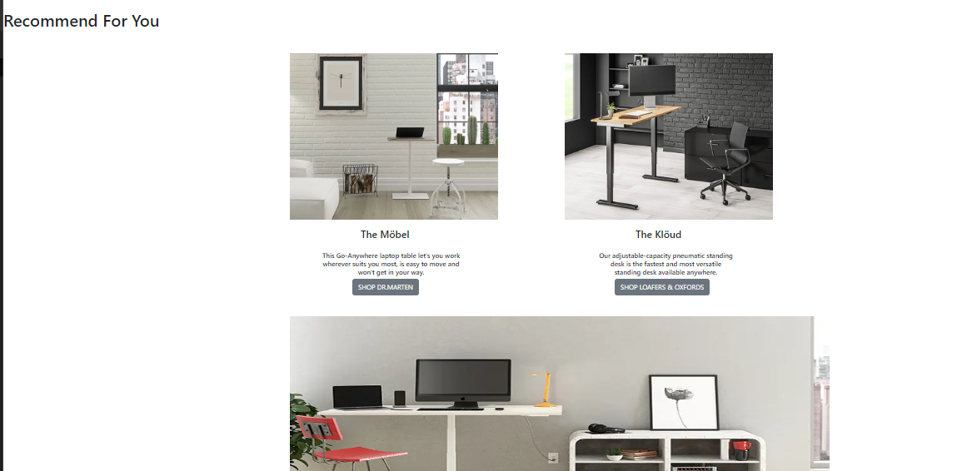

This page also includes the sign-up tag and the customer service content near the footer.

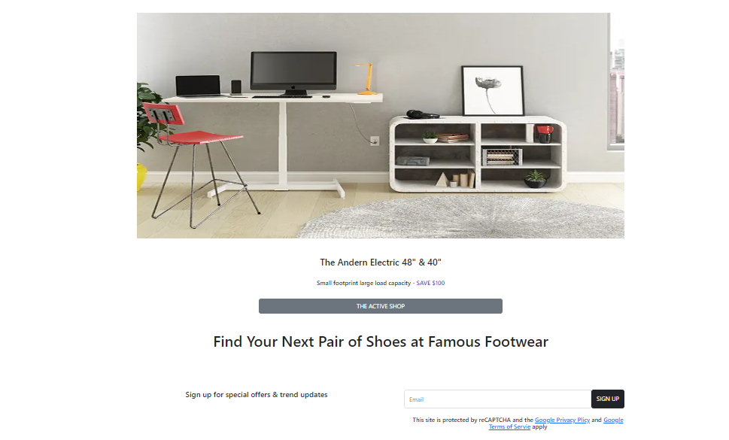

There are also services and benefit that are given for customers who will buy our products.

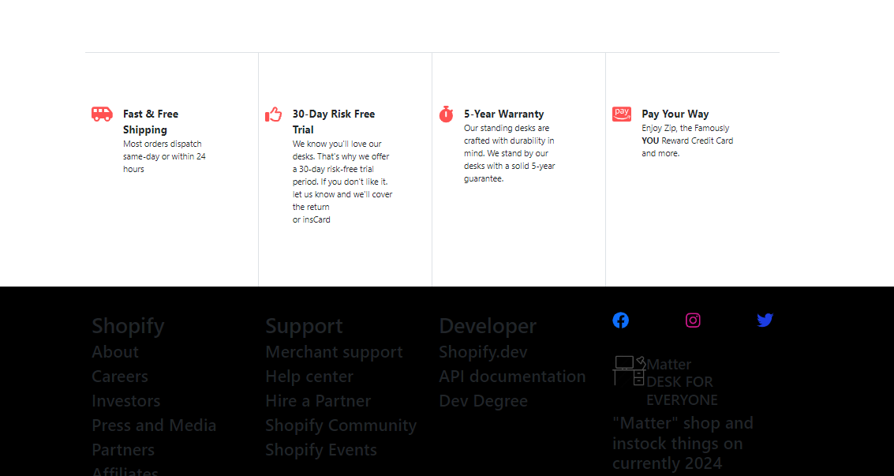

### **Contact us page**

This page shows the form for register. For register the customer write their first and last name, email and their info and also include the submit button drive the Gmail.

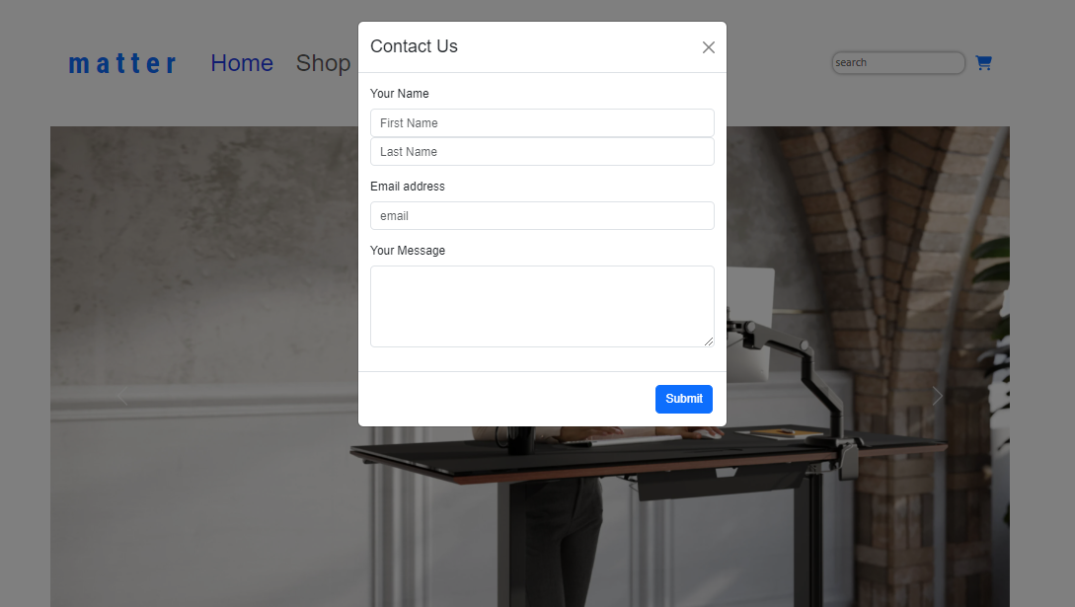

The contact form appears as transparent background for all pages.

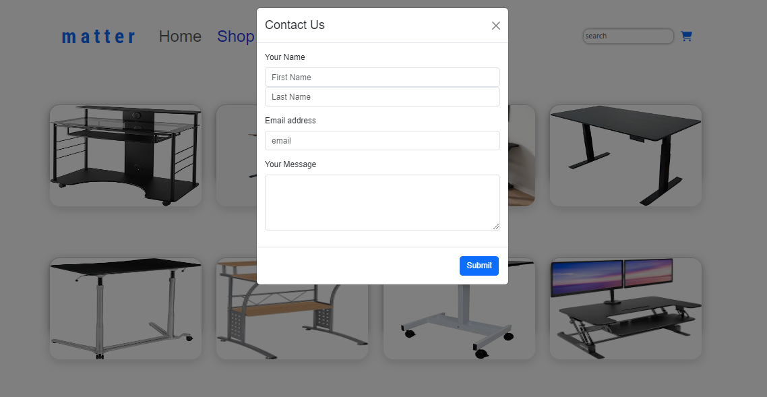

### **Login page**

This page includes the form for sign-up. Also include the Facebook and Twitter Link. The clink right mark in the tag of remember me help the user for the second times and Forget password also helps the users.

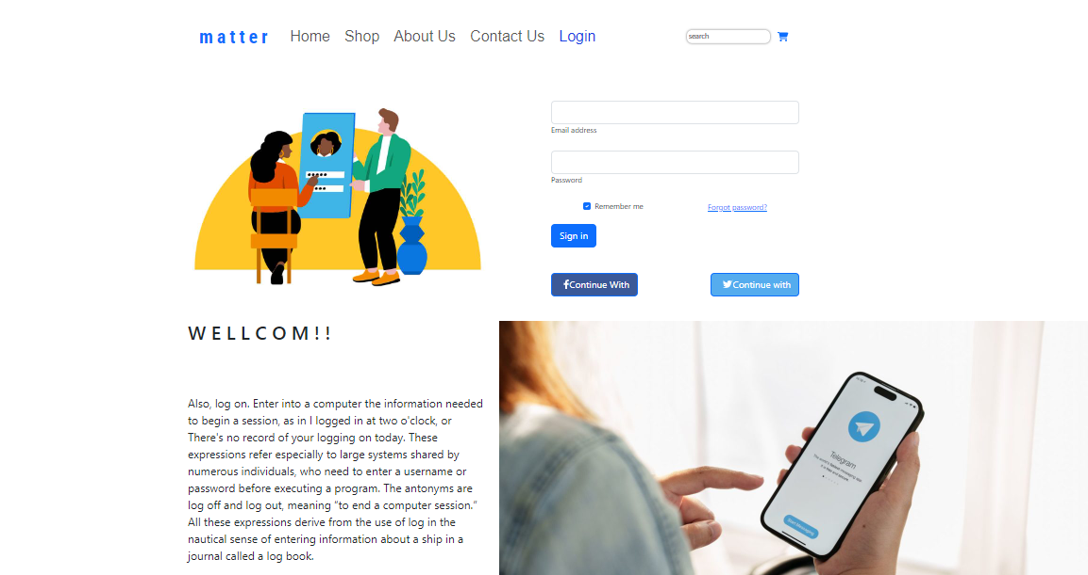

# **Task 2**

## **External CSS**

@import url('https://fonts.googleapis.com/css2?family=Barlow+Condensed:wght@300&family=Roboto+Condensed:wght@700&display=swap');

.logo a {

    font-size: 40px;

    text-decoration: none;

    letter-spacing: 0.2em;

    font-family: 'Roboto Condensed', sans-serif;

}

p {

    padding-top: 100px;

}

.mysearch {

    padding: 4px;

    font-size: 20px;

    border-width: 2px;

    border-color: #CCCCCC;

    background-color: #FFFFFF;

    color: #000000;

    border-style: hidden;

    border-radius: 11px;

    box-shadow: 0px 0px 5px rgba(66, 66, 66, .75);

    text-shadow: 0px 0px 0px rgba(66, 66, 66, .75);

}

.mysearch:focus {

    outline: none;

}

@media screen and (min-width: 400px) {

    .mysearch {

        padding: 3px;

        font-size: 15px;

        border-width: 2px;

        border-color: #CCCCCC;

        background-color: #FFFFFF;

        color: #000000;

        border-style: hidden;

        border-radius: 11px;

        box-shadow: 0px 0px 5px rgba(66, 66, 66, .75);

        text-shadow: 0px 0px 0px rgba(66, 66, 66, .75);

    }

}

#navbarNav {

    font-family: 'Kanit', sans-serif;

    background-size: cover;

}

#navbarNav a {

    margin: 5px 7px;

}

#navbarNav a:hover {

    background-color: rgb(226, 216, 216);

    border-radius: 25px;

    color: rgb(20, 16, 212);

}

#hello {

    animation-name: example;

    animation-duration: 2s;

    animation-fill-mode: forwards;

}

@keyframes example {

    from {

        left: 0px;

    }

    to {

        left: 10px;

    }

}

@media screen and (min-width: 400px) {

    .navbar-toggler {

        margin-right: 400px;

    }

}

.data a {

    text-decoration: none;

    color: white;

}

@media screen and (min-width: 400px) {

    #content-photo {

        width: 100%;

    }

}

.login {

    align-items: center;

    justify-content: space-between;

    margin-top: 30px;

}

.card a {

    width: 30px;

}

.card {

    margin-top: 50px;

}

.card .infor {

    display: flex;

    justify-content: space-between;

}

.footer {

    background-color: black;

    text-decoration: aliceblue;

}

.footer-link {

    justify-content: space-between;

    display: flex;

}

.footer-logo {

    display: flex;

    align-items: center;

}

.footer-logo h3 {

    padding-top: 50px;

}

.fa-store {

    width: 100px;

}

.toast {

    width: 500px;

    position: absolute;

    left: 100px;

    top: 250px;

    background-color: rgb(250, 248, 253);

}

/*1.html of css*/

#card2 {

    width: 300px;

    height: 100px;

    background-color: rgb(255, 255, 255);

    border-radius: 20px;

    box-shadow: 2px 6px 8px 0 rgba(12, 12, 12, 0.2), 0 6px 20px 0 rgba(0, 0, 0, 0.19);

    margin-bottom: 100px;

    transition: 0.5s;

    padding-bottom: 150px;

}

#card2:hover {

    height: 500px;

}

.photo {

    position: absolute;

    width: 300px;

    height: 200px;

    border-radius: 20px;

    overflow: hidden;

    transition: 0.5s;

    box-shadow: 3px 6px 8px 0 rgba(255, 243, 255, 0.363), 0 6px 20px 0 rgba(0, 0, 0, 0.19);

}

#card2:hover .photo {

    width: 300px;

    height: 300px;

}

.info {

    width: 100%;

    transition: 0.5s;

    overflow: hidden;

}

#card2:hover .info {

    margin-top: 300px;

}

.info h2 {

    font-size: 25px;

    font-family: Impact, Haettenschweiler, 'Arial Narrow Bold', sans-serif;

    padding-top: 20px;

    padding-left: 30px;

}

.data {

    display: flex;

    justify-content: space-between;

    transition: 0.5s;

    padding-top: 20px;

}

.data h3 {

    justify-content: space-between;

    font-family: Verdana, Geneva, Tahoma, sans-serif;

    padding-right: 15px;

    font-size: 20px;

    overflow: hidden;

    transition: 0.5s;

}

.p {

    background-color: #7892c2;

    border-radius: 28px;

    border: 1px solid #4e6096;

    display: inline-block;

    cursor: pointer;

    color: #ffffff;

    font-family: Arial;

    font-size: 17px;

    padding: 20px 40px;

    text-decoration: none;

    text-shadow: 0px 1px 0px #283966;

}

.p:hover {

    background-color: #476e9e;

}

.p:active {

    position: relative;

    top: 1px;

}

.o {

    background-color: #44c767;

    border-radius: 28px;

    border: 1px solid #18ab29;

    display: inline-block;

    cursor: pointer;

    color: #ffffff;

    font-family: Arial;

    font-size: 17px;

    padding: 20px 30px;

    text-decoration: none;

    text-shadow: 0px 1px 0px #2f6627;

}

.o:hover {

    background-color: #5cbf2a;

}

.o:active {

    position: relative;

    top: 1px;

}

/*1.html of css*/

.divider {

    height: 5px;

}

#login2 p {

    font-size: x-large;

    font-family: 'Segoe UI', Tahoma, Geneva, Verdana, sans-serif;

}

# **Tasks-3**

## **Test the website and write a test report**

## **Problems while testing and recommendation for fixing them**

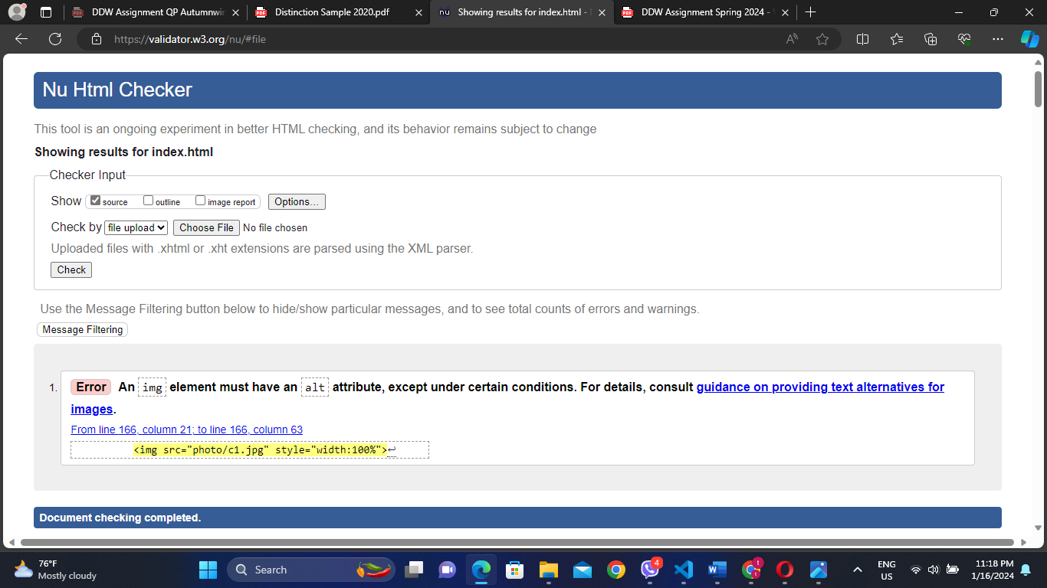

There is an error in img tag in html. I forgot to put alt attribute in line 166.

Now my Document is no error after solving that.

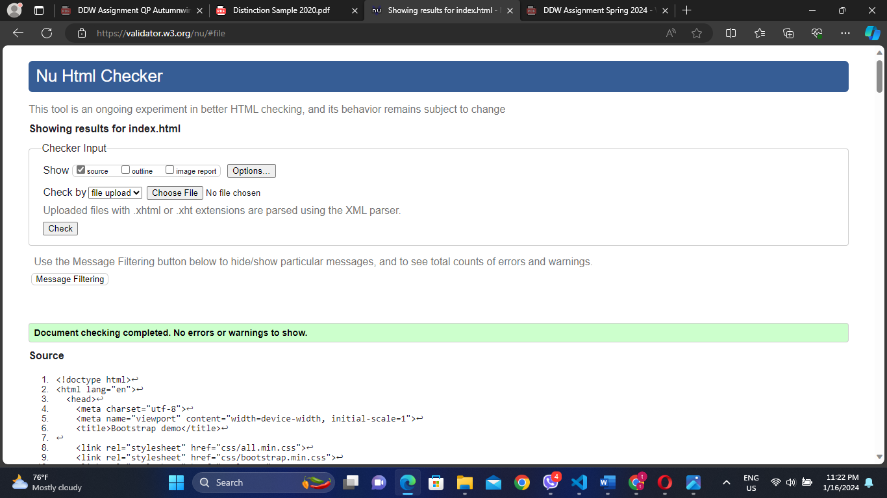

## **Testing with relevant screen reader**

NVDA (Non-Visual Desktop Access) allows blind and vision impaired people to access and interact with the Windows operating system and many third-party applications. I use it as a screen reader. It can do automatic announcement of text under the mouse and optional audible indication of the mouse position. It can translate into more than 50 languages. It can report the textual formatting where available such as font name and size, style and spelling errors.

## **Discrepancies and identify and rectify their causes**

The content photos are not responsive when our website on mobile. The size of the photo is big and the all of size is invisible.

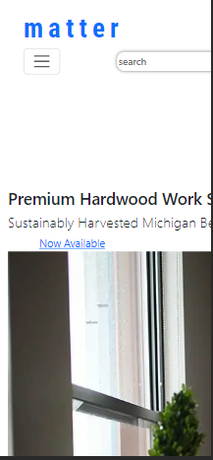 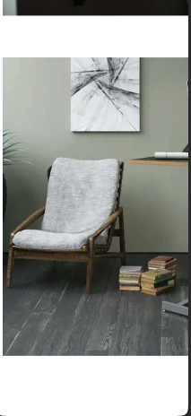

This error is solved by using @media in CSS.

I wrote the below photo in CSS.

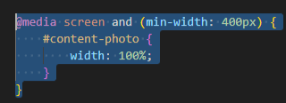

 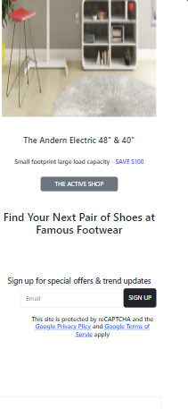

## **Differences between two browsers**

In Chrome and Opera, there is the same size when pass from one page to another page

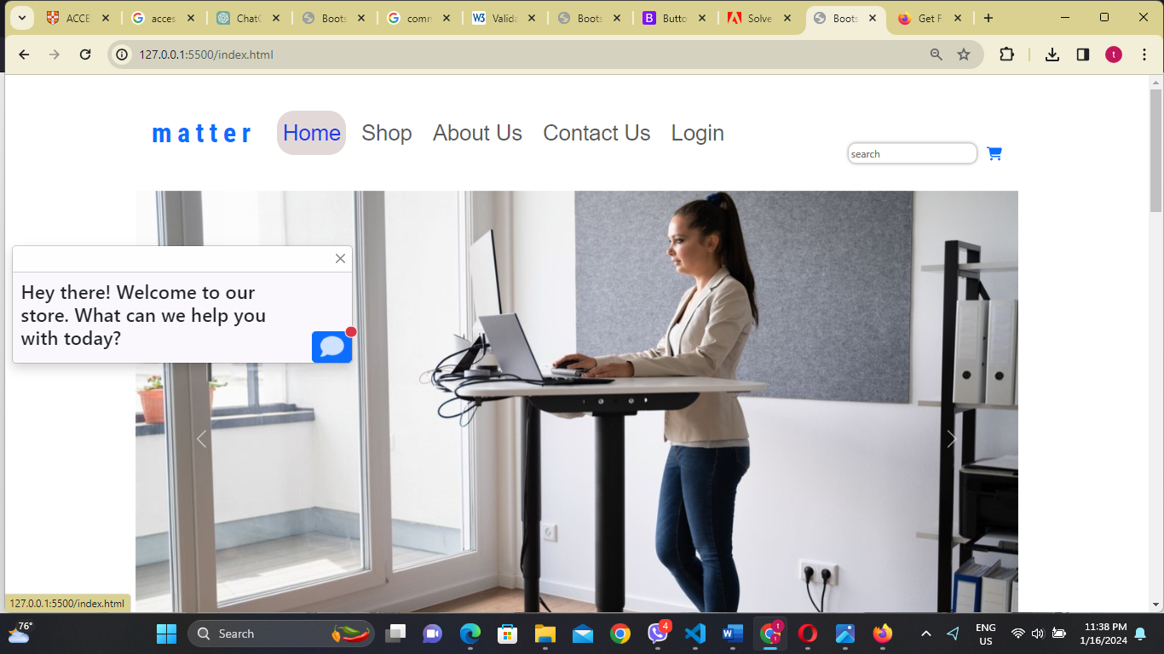

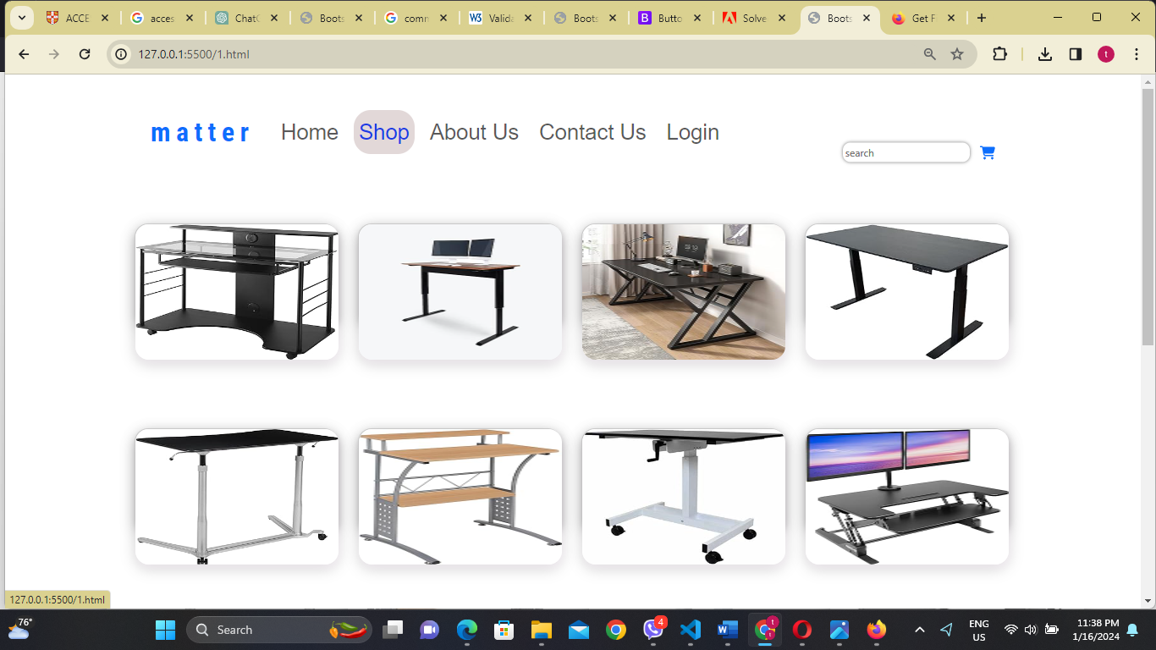

But in Firefox, the sizes are not same by passing one to another pages.

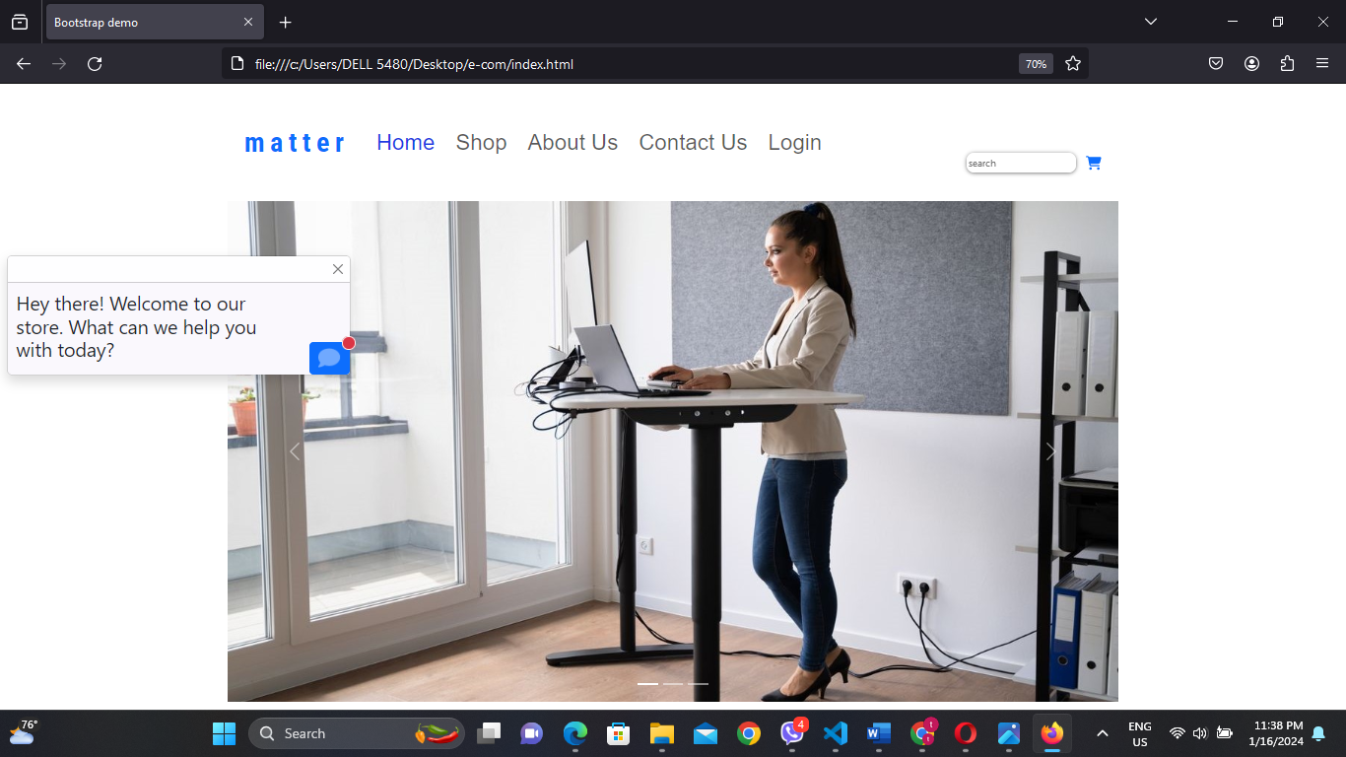

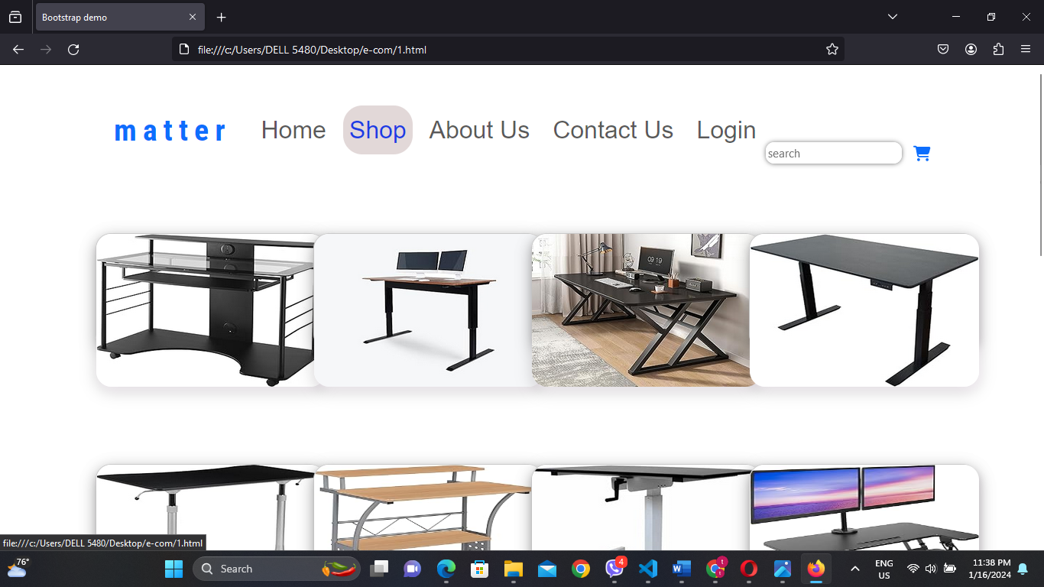

## **Report**

I have some error and tried to fix them in creating this website. Ther was a few problems in creating in responsive design for every position and display size. For example, the box’s size may change in specific numbers when the desktop size is 480px etc. And I deeply focused in shop page. The item box is expanded when the mouse is reaching on it. I have faced the duplication of html tag and attributes. Also, I considered that how many columns may be put in a row.

The pages lack proper formatting. I find myself repeatedly adjusting them to make them display correctly. These issues affect both the appearance and functionality of the webpage. Some errors are related to the visual design, while others impact the features of the webpage. I need to consistently address these concerns to maintain a graceful and effective web pages.

There was non-fix of photo content and button in mobile phone size. So, I tested and changed the CSS to fix them in mobile size.

# **Task-4**

## **The suitability of the tools, techniques and software used to develop the website**

Web design tools and software are user interfaces that support in the creation of websites or components for a website. Each tool or software provides a diverse set of features to allow we to personalize our website according to our preferences and requirements. Additionally, many web design tools provide IT assistance and a range of helpful resources, including tutorials and guides, to support we throughout the website creation process.

* Ease of use: For those just starting in web design, there are numerous tools and software options designed for beginners. Even without coding or graphic design expertise, specific web design tools simplify the learning process, enabling us to swiftly create a straightforward web interface.
* Design control: With web design tools, we have the freedom to personalize our site using the features provided by the software. For instance, we can modify specific elements on our website to a color that aligns with our client's preferences.
* Cost-Effectiveness: Numerous web design tools and software offer free or reasonably priced plans. Even though premium plans provide enhanced or advanced capabilities, you can still develop a basic and functional site without breaking the bank.

## **(b) how intuitive interfaces contribute to delivering an improved user experience**

Effective UI (User Interfaces) design combines both aesthetics and functionality. It should not only be visually appealing but also empower users to effortlessly accomplish their tasks. The purpose of the user interface is to supply to user needs, and a well-designed interface contributes to increased user adoption, fewer errors, and savings in both user time and frustration. User retention is the measure of how many users continue to use our website while using. A good interface can help increase the user retention rate by reducing defeat and improving the ease of use.

An excellently created interface sends information in a clear manner. Clear icons, labels, and visual signs help users grasp the intent and functionality of various elements. A UI that's easy to use helps users navigate our software effortlessly, access features, and complete tasks. An intuitive UI makes it easier for users to achieve their goals without facing a steep learning curve.

## **(c) Suitability of the accessibility**

"On this website, you'll find a convenient search box at the right side of every page to help users find what they're looking for. There is a menu at the top that is designed with links to every page, ensuring easy navigation to their respective destinations. Clicking on the logos of popular platforms such as Facebook, Instagram, Twitter, and Gmail will seamlessly forward users to the corresponding pages.

This website is optimized for mobile use, allowing users to perform the same actions on their mobile devices as they would on a desktop or laptop. Whether on a computer or a mobile device, the user experience remains consistent and efficient."

## **(d) Recommend improvements for further development of the website**

By Keeping our website filled with valuable content serves, it keeps existing subscribers informed and provides essential details for potential new visitors to become customers. This ongoing engagement helps build lasting loyalty among our audience, resulting in regular visits that greatly enhance the overall value of our website.

Page speed affects our search engine rankings because slow sites negatively affect user experience and our products for sales in dely. Page speed is important to users because, well, faster pages are more efficient and provide a much better on-page user experience.

To kick things off, it's a good idea to ensure our website aligns with fundamental design principles. Furthermore, incorporating eye-catching visual elements into our site can establish a memorable design, distinguishing us from competitors and rapidly taking our audience's attention.

# References

Avishai Abrahami, N. A. (2006). *WIXBlog*. Retrieved from Wix: https://www.wix.com/blog

Information Technology & Services. (2003). *seoClarity*. Retrieved from http://www.seoclarity.net